Spring Concert, Part 2
Mandatory for: Jazz Band, Intermediate Band, and Advanced Band
May 23, 2018, in the CMS Cafeteria
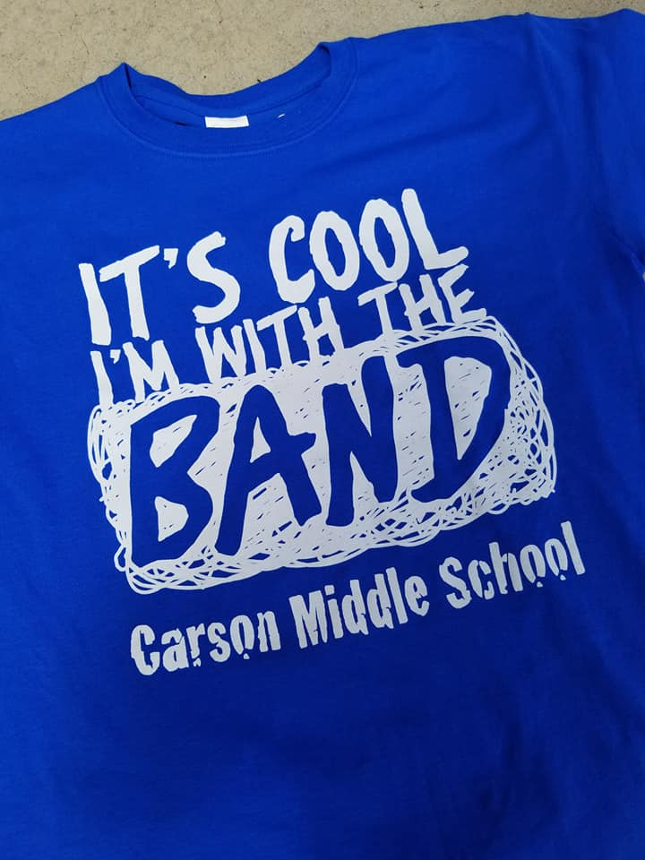
5:00 Call Time in Band Room for all ensembles.
5:30 Jazz Band performs
6:00 Intermediate Band performs
6:20 Advanced Band performs
7:00 Approximate end of concert. Please stay and support your fellow musicians in other ensembles.

Concert Outfit
Blue cummerbund (vest or jacket for some) and bow tie, white tuxedo shirt, black dress pants, black socks, and black shoes.

Tee Shirt Sale
- This year’s band shirts will be sold at the concert for $10 each

Spring Concert, Part 2
Mandatory for: Jazz Band, Intermediate Band, and Advanced Band
May 23, 2018, in the CMS Cafeteria
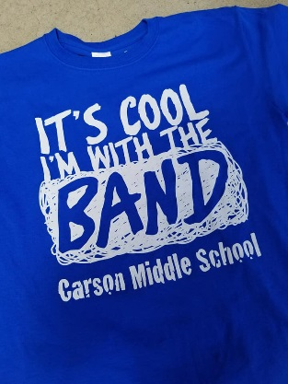
5:00 Call Time in Band Room for all ensembles.
5:30 Jazz Band performs
6:00 Intermediate Band performs
6:20 Advanced Band performs
7:00 Approximate end of concert. Please stay and support your fellow musicians in other ensembles.

Concert Outfit
Blue cummerbund (vest or jacket for some) and bow tie, white tuxedo shirt, black dress pants, black socks, and black shoes.

Tee Shirt Sale
- This year’s band shirts will be sold at the concert for $10 each

